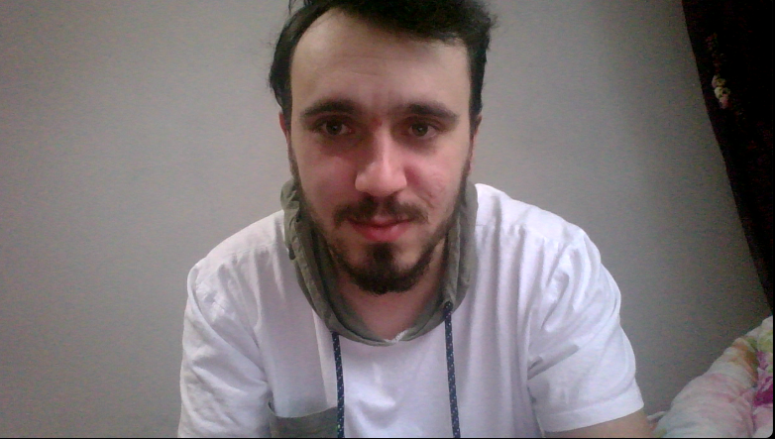

FATİH SAĞLAM

He was born on May 26, 1998 in Trabzon. He completed all his education until high school in Trabzon. In 2017, he won the Computer Engineering Department of Adnan Menderes University. He still continues his university education.Since his financial situation is not very good and he does not want to be a burden to his family, he pays his education expenses by working in holiday regions in the summer.

Github User Name : fatih-61